 | Course Name: Design Patterns/Thinking LAB | EXPERIMENT NO. 10
 | Course Code: 20CP210P  Faculty: Dr. Ketan Sabale | Branch: CSE | Semester: IV
(To be filled by Student)
Submitted by: Manan Kapkar
Roll no:23BCP336

Objective: To familiarize students with standard Creational design patterns.
Experiment: Explain the decorator design pattern and write a program using any object-oriented programming language to demonstrate the working of decorator design pattern.
Decorator Design Pattern:
- The Decorator Design Pattern is a structural pattern that allows behavior to be added to individual objects dynamically, without affecting the behavior of other objects from the same class.
- The Decorator pattern attaches new responsibilities to an object at runtime by placing it inside special wrapper objects called decorators. Each decorator class implements the same interface as the object it wraps, ensuring transparency and flexibility.

Structure:
- Component: Interface for objects that can have responsibilities added.
- ConcreteComponent: The original object to which new behavior can be added.
- Decorator: Abstract class that implements Component and holds a reference to a Component.
- ConcreteDecorator: Adds behavior to the component by extending the decorator class.

Advantages:
- Flexible extension of behavior: Add or modify behavior without changing the original code.
- Open/Closed Principle: You can extend functionality without modifying existing classes.
- Runtime behavior change: Behaviors can be combined dynamically at runtime.
- Avoids subclass explosion: Compared to creating many subclasses for every combination of behavior.

Disadvantages:
- Increased complexity: Many small classes can make code harder to read and maintain.
- Debugging difficulty: Tracing logic through nested decorators can be tricky.
- Order sensitivity: The order in which decorators are applied may affect behavior.
- Not as transparent: Clients must be aware of the composition of decorators in some cases.
Class Diagram:
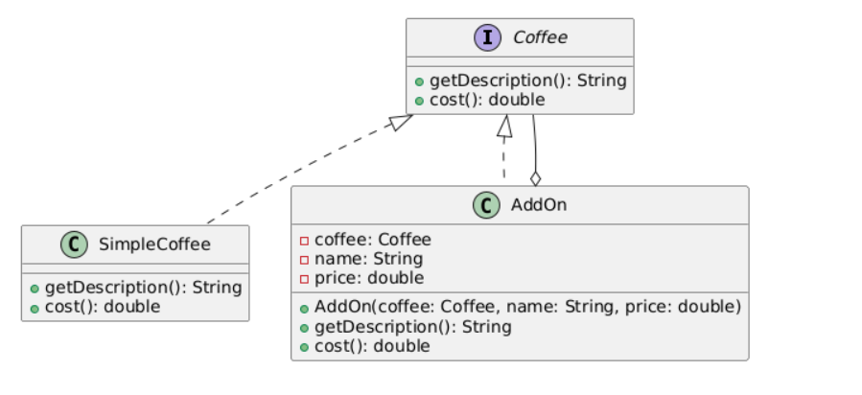

Code:
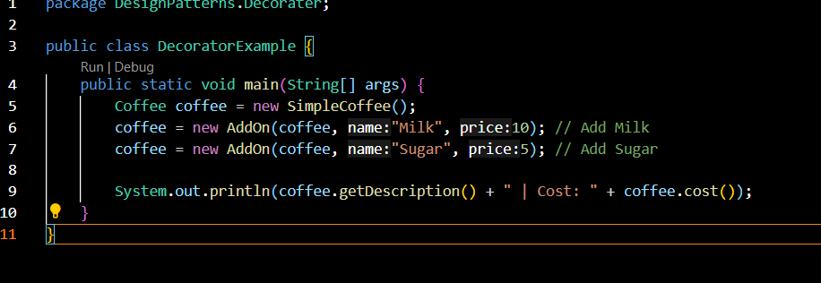
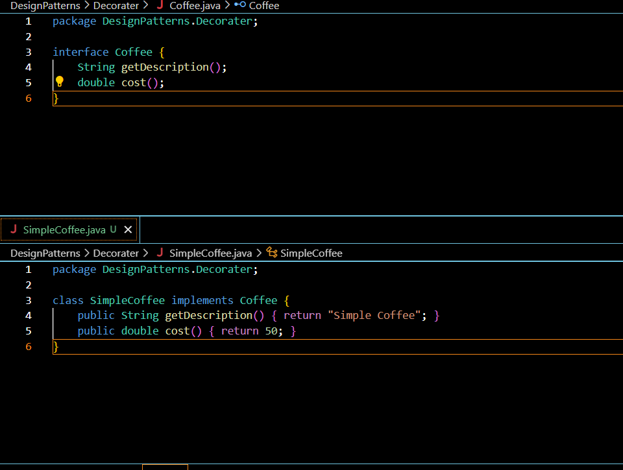
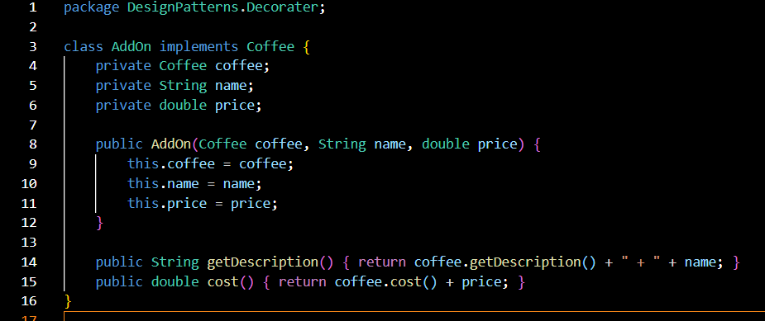

Output:
